**Name:** Carlos Carrillo-Calderon

01/07/2016

**OSU ID:** 932698326

**Assignment 0**

**PART 1: Introduce Yourself**

I am from Colombia, but I live in Chicago North Suburbs. I decided to pursue a degree in Computer Science since I have a BS degree in Electronics engineering that I have never used and now I feel it's to come back to science. The reason why I never used it was because I was simultaneously doing a BA in linguistics and my own destiny brought me through the linguistic path instead.

I came to this country 7 years ago after I was awarded a scholarship to study English and to be a Language advisor for the University of Wisconsin. Then, I met my wife and decided to stay in the U.S and do a M.A in Hispanic linguistics and literature (also at the University of Wisconsin). After that, I got accepted to a Ph.D. program in Hispanic linguistics at the University of Illinois. So now I would like to see if I could put together all what I have learned and focus on Computational Linguistics or something similar (if it is possible and I don’t change my mind ;-)).

Currently. I am an Associate Editor/Translator at Pearson Education at the Math department. We create Math textbooks for kids from Grade K-6 in both English and Spanish. I love to watch documentaries, ride my bike, play my electric guitar, and snuggle my wife and my two Chihuahuas.

**Programming Experience**

Before beginning this program, I had almost no programming experience (just a little bit of Assembly Language for Intel micro-processors). My experience programing really boils down to the C++ I’ve learned in CS_161 and CS_162. For C++, I initially worked in VIM for about a week but then started using Xcode and haven’t looked back. I wrote pretty much all my programs in Xcode and then would test them on FLIP.

**PART 2: Environment Setup**

I chose Xcode as my suitable programming environment with a debugger. Fortunately, it works very smoothly for me. These are the screenshots to show my work:

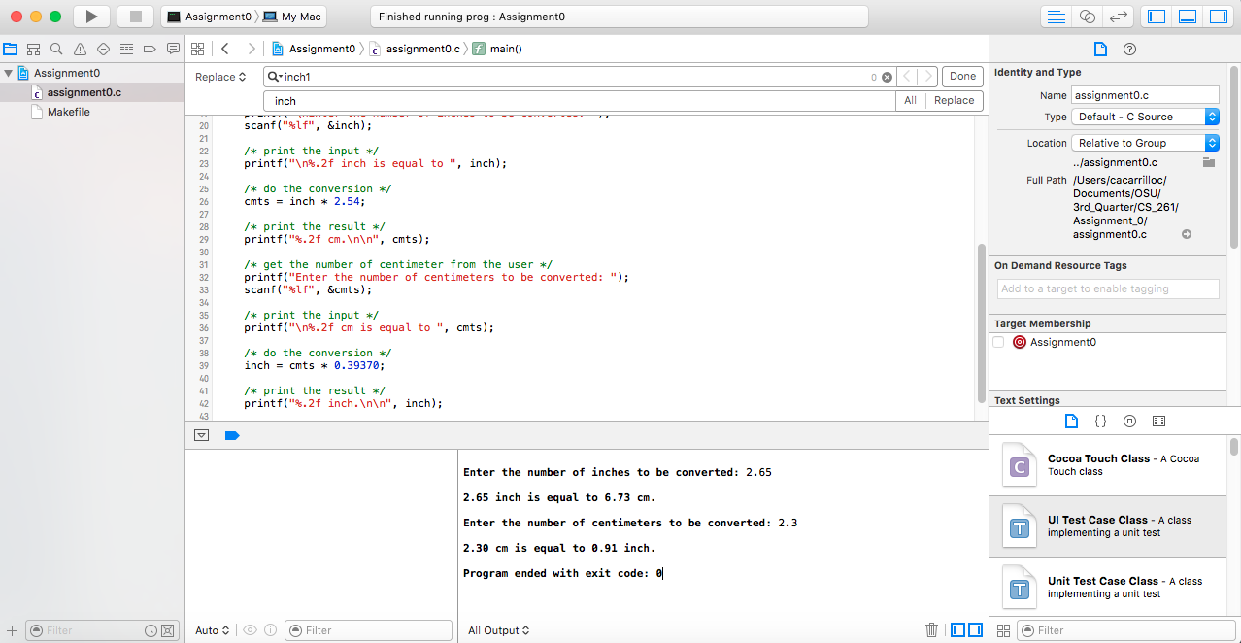

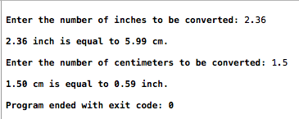

**Compiling/executing on flip.engr.orst.edu:**

First, I just used FileZilla to transfer the program files to my folder in the OSU:

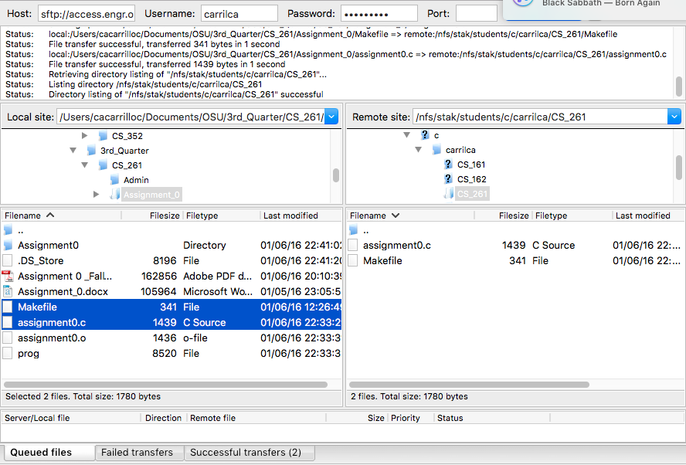

Then I went to the OSU server itself and compile the program using a Makefile:

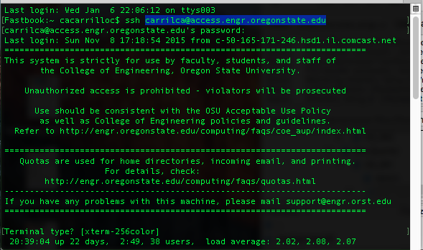

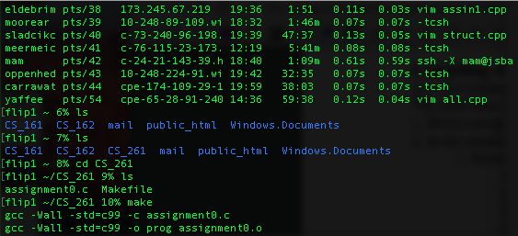

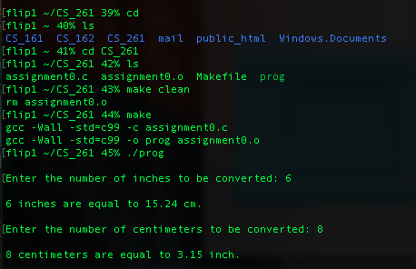

**My first C program for this course:**

